Exercise

01.

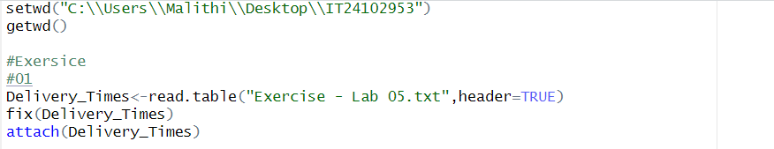

02.





03.



04.





